Final Project Report

Team Members:
- Mansi Nagar
- Aryansh Fooria
- Palash Rathi
- Biswajit Saha

Q1.
A1. Data used & preprocessing
- Tickers (two industries, with inverse ETFs):
  - Healthcare: Stock = JNJ, inverse ETF = RXD
  - Energy: Stock = XOM, inverse ETF = ERY
  - Benchmark: Fama–French MKT factor
- Frequency: Monthly EOM (end-of-month):
- Return transformation: Log returns for each ticker:
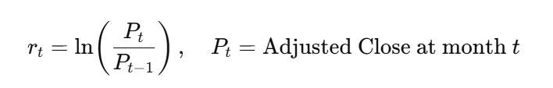
Time window: Last ~5 years ending at the latest available EOM across all four tickers
  - Full overlapping window (after EOM alignment): 2020-11-01 → 2025-08-01
- Train/Test split (per instruction: use part of the sample for setup):
  - Train (75%): 2020-11-01 → 2024-05-01
  - Test (25%): 2024-06-01 → 2025-08-01
  - Counts (per industry pair after merging): n_full=58, n_train=43, n_test=15
The corresponding Excel sheets contains the log return calculations are attached below.
..\RXD LOG RETURNS.csv
../XOM%20Log%20Returns.csv
../ERY%20Log%20Returns.csv
../JNJ%20Log%20Returns.xlsx

A1b. Fama–French MKT factor preparation
- monthly Mkt−RF and RF (in %).
- Converted to market total return MKT by (Mkt−RF+RF)/100 and then to log returns:
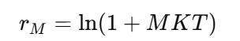
- Merged by calendar month with each portfolio’s test window for comparisons.

Q2.
A2. Method
- Let S be the industry stock (industry proxy), I the inverse ETF.
- 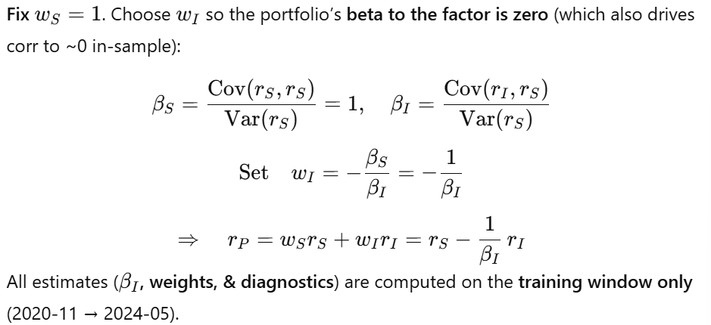Then we freeze the weights and evaluate out-of-sample on test (2024-06 → 2025-08).

A2.1 Healthcare portfolio (JNJ + RXD)
Training window numbers
- 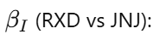 −1.368513
- Corr(S, I) in training: −0.751856 (appropriately negative for an inverse)
- Proof of neutrality (training):
  - Portfolio corr vs industry (JNJ): −1.75×10⁻¹⁶ ≈ 0
  - Portfolio beta vs industry: −1.53×10⁻¹⁶ ≈ 0
Dates & counts (after EOM alignment):
- Full: 2020-11-01 → 2025-08-01 (n=58)
- Train: 2020-11-01 → 2024-05-01 (n=43)
- Test: 2024-06-01 → 2025-08-01 (n=15)
Worked example (first month of test, 2024-06-01):
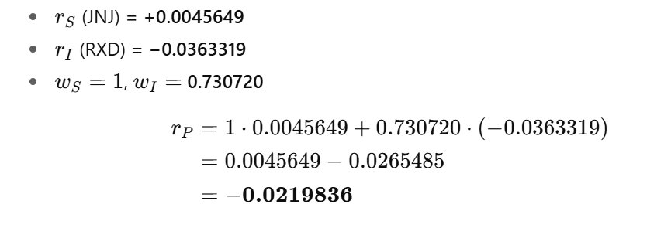
A2.2 Energy portfolio (XOM + ERY)
Training-window numbers:
- 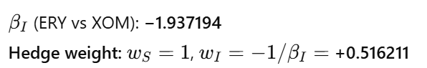Corr(S, I) in training: −0.896773 (strongly negative)
- Proof of neutrality (training):
  - Portfolio corr vs industry (XOM): −7.49×10⁻¹⁷ ≈ 0
  - Portfolio beta vs industry: −3.69×10⁻¹⁷ ≈ 0
Dates & counts (after EOM alignment):
- Full: 2020-11-01 → 2025-08-01 (n=58)
- Train: 2020-11-01 → 2024-05-01 (n=43)
- Test: 2024-06-01 → 2025-08-01 (n=15)
Worked example (first month of test, 2024-06-01):
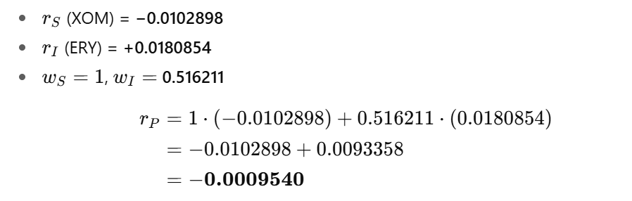 Both industry portfolios are long stock and long inverse ETF and are industry-neutral in-sample by construction (corr ≈ 0; beta ≈ 0).

The optimized portfolios for the two selected industries, constructed using a combination of industry stocks and their corresponding short/ultrashort ETFs to achieve zero correlation with the industry, are attached below in the Excel sheets.
../Enery%20Portfolio.xlsx
../Healthcare%20Portfolio.xlsx

Q3.
A3.1 Risk-measure formulas (applied to test-window log returns)
Let rrr denote the monthly log-return series of the portfolio over the test window.
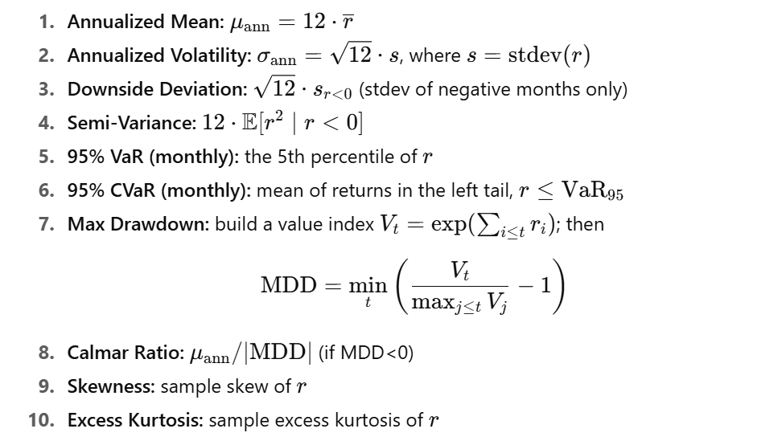
A3.2 Results
Healthcare-neutral (JNJ + RXD)
- Ann. Mean (log): 0.255751
- Volatility (σ): 0.168372
- Downside Deviation: 0.037091
- Semi-Variance: 0.008262
- 95% VaR (monthly): −0.035017
- 95% CVaR (monthly): −0.035384
- Max Drawdown: −0.034765
- Calmar Ratio: 7.356579
- Skewness: 0.654015
- Excess Kurtosis: −0.240620
- N (months): 15
- Tail detail (VaR/CVaR): 1 month in tail (of 15)
Energy-neutral (XOM + ERY)
- Ann. Mean (log): −0.009042
- Volatility (σ): 0.093110
- Downside Deviation: 0.087602
- Semi-Variance: 0.014366
- 95% VaR (monthly): −0.050531
- 95% CVaR (monthly): −0.066091
- Max Drawdown: −0.082086
- Calmar Ratio: −0.110158
- Skewness: −1.287354
- Excess Kurtosis: 1.314116
- N (months): 15
- Tail detail (VaR/CVaR): 1 month in tail (of 15)
Interpretation :
• Healthcare shows strong positive annualized log return with moderate vol, tiny drawdowns, and excellent Calmar, plus mildly positive skew.
• Energy shows slightly negative annualized return, lower vol but meaningfully worse tail (deeper drawdown, more left-skew, fat-left tail), leading to a negative Calmar.

Q4.
A4.1 FF MKT overlap & comparison (test window intersection)
We aligned each portfolio’s test returns with the FF MKT log returns.
Overlap dates: 2024-06-01 → 2025-06-01
- Overlap N: 13 months (for both portfolios)
Metrics (annualized) & formulas:
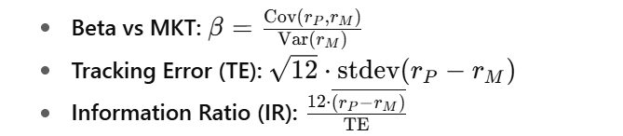Results:
- Healthcare-neutral (JNJ+RXD):
  - Beta vs MKT: −0.458107
  - TE (annualized): 0.229945
  - IR (annualized): +0.051940
- Energy-neutral (XOM+ERY):
  - Beta vs MKT: −0.509449
  - TE (annualized): 0.209379
  - IR (annualized): −0.839096
Interpretation:
Both hedged portfolios have slightly negative market beta (they’re hedged against their industry, not the market). Healthcare shows a small positive IR (edge vs MKT), while Energy shows a negative IR (underperformance vs MKT on a risk-adjusted basis).
A4.2
I would hold the Healthcare-neutral portfolio (JNJ + RXD).
- Out-of-sample performance: Annualized mean 0.256 with σ=0.168 and a tiny MDD (−3.48%) → Calmar ≈ 7.36. That is excellent risk-adjusted behavior with shallow drawdowns.
- Tail behavior: VaR/CVaR are shallow (≈−3.5%), consistent with drawdown stability; skew is positive and excess kurtosis near zero → benign tails.
- Versus MKT: Positive IR (+0.052 annualized) on the overlap indicates a slight risk-adjusted edge vs broad market.
- Energy’s drawbacks: Out-of-sample negative annualized mean (−0.009), worse drawdown (−8.21%), left-skewed with fat-left tail (excess kurtosis > 1), and negative IR (−0.839). Despite lower σ, its risk-adjusted profile is inferior.
Conclusion: Healthcare-neutral delivers a superior risk/return profile out-of-sample and a slight edge relative to MKT on overlap, making it the more compelling choice.

Appendix — Key Calculation Walkthroughs
A. Hedge weight computation (training window)
For each industry:
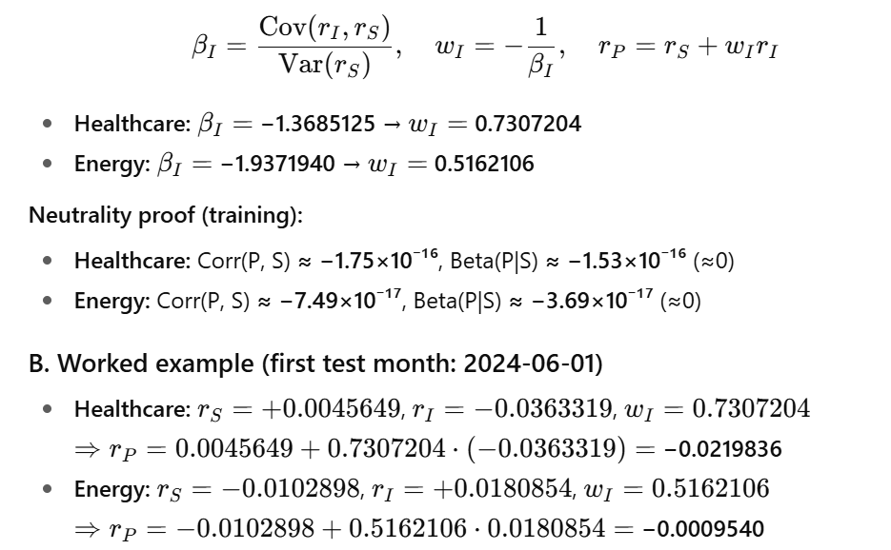
Neutrality proof (training):
- Healthcare: Corr(P, S) ≈ -1.75 × 10^{-16}, Beta(P|S) ≈ -1.53 × 10^{-16} (≈ 0)
- Energy: Corr(P, S) ≈ -7.49 × 10^{-17}, Beta(P|S) ≈ -3.69 × 10^{-17} (≈ 0)
B. Worked example (first test month: 2024-06-01)
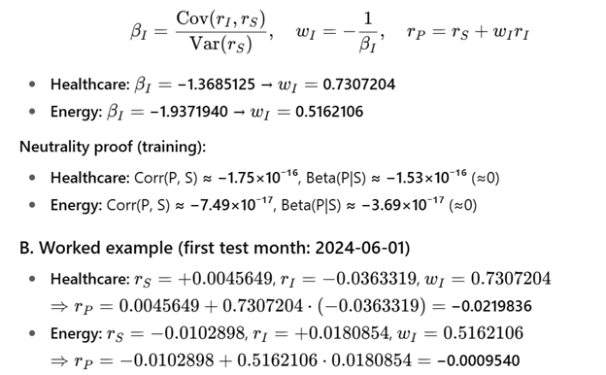
C. Risk metrics (test window)
